Tree cutting robot

Chainsaw on a scissor lift controlled by VR controllers

* Technology that tracks movement of something and robot that copies it. IR tracking.

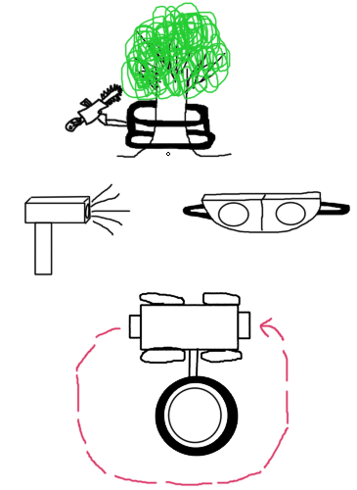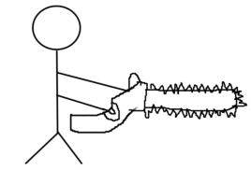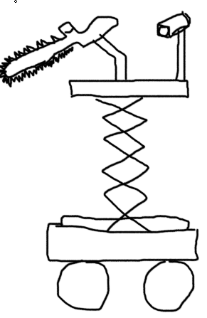

Or have a robot that encircles the tree and can ascend and descend. Use a foot pad to send signals to it.

VR goggles hooked up to camera to see the movement of the fake saw.

Have a fake chainsaw you hold hooked up wirelessly or wired through scissor lift to a real chainsaw. Your movements will be mimicked by the real chainsaw.